Contraception Discontinuation Testing Summary
Addressed to each testing team
Write testing dates here : __________________________
Objectives of this activity
In the Philippines, research around the motivations, behaviors and impact of contraception discontinuation is insufficient.

This activity aims to address the following areas:
- To gain awareness of the Filipino woman’s individual reproductive journey as a whole, including her views, biases, barriers, and circle of influence.

- To identify potential barriers and areas for intervention within the Filipino woman’s family and community.

- To understand how healthcare providers (HCPs) can pivot from a possible prescriptive mentality to one that is oriented on having an equal and sustainable partnership with the client.

- To identify potential areas within the HCP and client relationship; build empathy to improve interpersonal trust and communication as well as channels for support and assistance.
Please consult the Intent Statement developed by the various parties involved in this activity for more information.
Strategic shifts
Reducing contraceptive discontinuation by going from:
↘ “Assumptions of the woman’s reproductive journey (i.e., transition points, circle of influence in woman’s decision making around contraceptive usage)”
to:
↗ “Awareness of the woman’s individual reproductive journey as a whole (i.e., her views, biases, barriers and circle of influence)”
second, from:
↘ “Assumptions on the views and barriers of the woman’s partner, family and immediate community around contraceptive usage”
to:
↗ “Identification of potential barriers and areas for intervention within the woman’s family (including her partner) and community”

third, from:
↘ “HCPs having a prescriptive mentality when dealing with their clients”
to:
↗ “HCPs having an equal and sustainable partnership with clients (the woman”

last, from:
↘ “Lack of knowledge around relationship dynamics and inconsistencies within HCP and client (the woman) relationships”
to:
↗ “Identification of potential areas for building empathy so it may lead to improving interpersonal trust and communication and HCP channels of support and assistance”

Objectives of this round of test
To address the objectives of this activity, 6 preliminary solutions have been conceived to be tested by target audiences: contraception users and discontinuers, influencers, and HCPs. The solutions will be prototyped so they can be tested, then adapted according to user feedback. This process will be repeated twice, with a second test sprint.
The first testing sprint aims to evaluate the prototypes’ desirability, by assessing the following:

Perceived advantages - How do these prototypes positively influence past or current practices?

Engagement - To what extent can users interact with the prototypes and what could motivate them to use the prototypes in the mid and long terms?

Perceived value - Are these prototypes perceived as easy to use, and is their use perceived as beneficial?

Adoptability - To what extent can users experience or practice the new behavior before adopting it?
Simplicity - To what extent is the innovation perceived as relatively easy to understand and use?
The second testing sprint will aim at testing feasibility, and an eventual pilot will assess the prototypes’ scalability.
Summary of test sprint #1
10 prototypes, 3 test teams, 6-7 Health Facilities in 3 locations, with 66 test participants.

The testing period will take place from June 23 to 27, 2022.
During these 5 days, the design team will divide into 3 groups to test the 10 prototypes in 6 health facilities (2 facilities per group) located in urban, peri-urban, and rural areas:
- One team traveled to Luzon, Cam Sur
- One team traveled to Visayas, Aloguinsan
- One team traveled to Mindanao, Zamboanga

The teams will test all 10 prototypes in each of the 6 health facilities with 22 users per area, a total of 66 users (see dashboard for the breakdown of users we will be testing with).

They will ensure that the prototypes are deployed in such a way as to collect as much relevant information as possible from the participants while respecting the barrier measures against Covid 19 and ensuring that people are willing to participate by reading and having them sign consent forms.

Dashboard

Fill in this dashboard (see example) for each testing team.
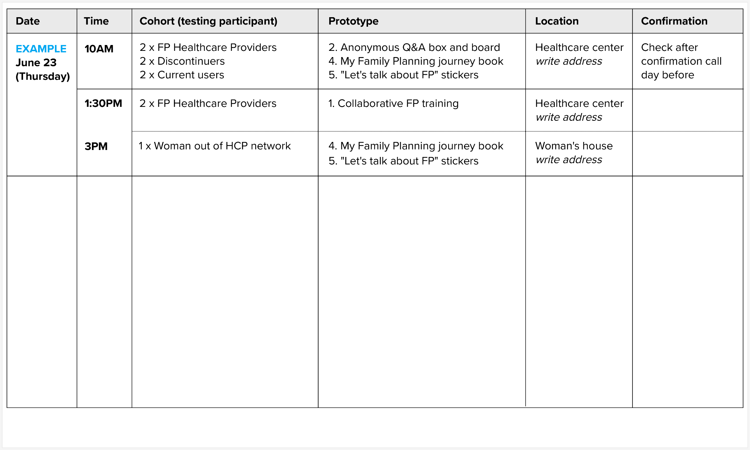

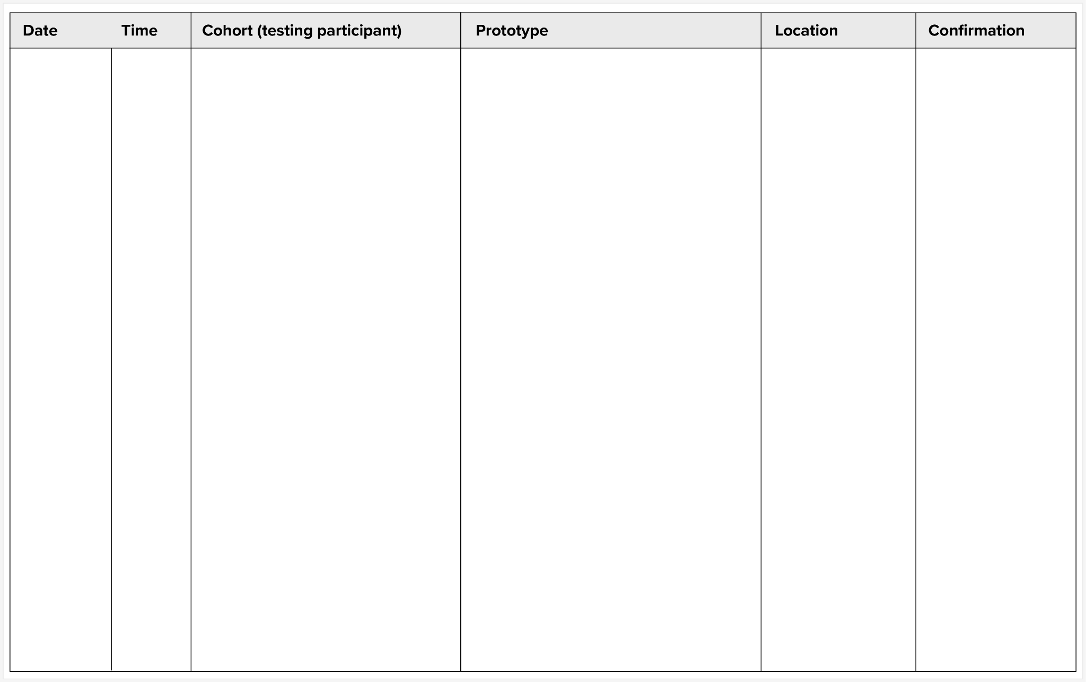

Roles among each testing team

In each team the following tasks should be assigned to a member. The objective is to have good coordination, communication and recording of activities to be performed.

Team coordinator and timekeeper
Person who has an overall vision of the activity in its different phases and its medium- and long-term objectives. This person is in charge of the dialogue with ThinkPlace on a daily basis, and between the key actors of the activity. This person is responsible for ensuring that all activities and logistics of the day are carried out successfully. This includes helping the team meet the time requirements for each test and helping to brainstorm solutions for problems that arise when traveling between health zones. Finally, he/she knows and follows the budgets, and ensures that the logistical and administrative aspects run smoothly.

Interview and consent manager and Translator
Person who has a facility for dealing with people and is fluent in the local language. He/she is responsible for explaining the activity to the participants, for the briefing necessary for the prototype to be tested. He/she interviews the participants with whom the prototypes are tested (instructions, questionnaires, feedback etc.). Before each interview, he/she makes sure that the consent forms are read and signed by the test participants.
The interview manager MUST verbally translate important details of the ongoing interview to the prototype packs in-charge into English if there is a need to further probe/pivot the interview in a different direction. This will also help the prototypes packs in-charge to collect full information around the prototypes.

Prototype packs in-charge
Person who is in charge of the good progress of the test in the quality of its content. He/she is in charge of the elements that make up each prototype, as well as the test guide. He/she must ensure that all the elements for each prototype are complete (forms and/or posters and/or objects, etc.), and that there is the necessary quantity for each trip.

He/she ensures that each prototype is tested in its entirety and in the most qualitative way possible: if an element is missing or if information has not been collected in the best way, this person intervenes.

This in-charge should sit next to the interview manager during the interviews in the case that there is a need to intervene during the interview.

Notes, debriefs, and transcription manager
Person who is fluent in the local language and is responsible for taking notes during the interview on the corresponding forms, as well as recording the participants' data on the participants' list. He/she will record comments and feedback during the test. This person will be responsible for typing the participant list and questionnaires on the computer at the end of the day and sending them to ThinkPlace.

He/she will be responsible for gathering his/her teammate at the end of the day to debrief the activities conducted online with ThinkPlace. He/she will take note of the reflections, recommendations, and adjustments to be made for the next day and record them in a document so that the information is not lost.

The notes manager should flag out during the interviews in the case that there is a need to intervene during the interview if the Interviewer is occupied.

Communication and photo tasks (Prototype packs in-charge)
Person in charge of communicating updates in the WhatsApp/Viber group and general communication between teams. He/she will coordinate needs and support between teams. This person is in charge of taking and transmitting photos during the activities, making sure that all people in the photo have their masks on and that distance rules are respected (see official USAID guide). User interaction with the prototypes should be visible and the light and definition should be good. The photos can then be sent to ThinkPlace on WhatsApp.

For roles in this sprint, see via this link / the following page.

Teams and roles overview

Name | Phone & email | Role(s) while testing | Organization
Team # __
Team # __
Team # __

To remember during testing sprint

Daily debrief within each team
We suggest that each team meets after the day of interviews in person at 6PM to debrief on the important things that happened and make necessary adjustments.

Collective debrief every other day
Please join a collective debrief on day 1, day 3, and day 5 at 6PM on this link :

Documents required for each day of testing

- The prototypes you will be testing today.

- Questionnaire-note taking templates for each team to fill in during the prototype testing. This will enable you to note the participants' responses to our lines of inquiry. Take one template per prototype and per participant.

- One consent form per participant (22 copies per region).

- The list of test participants, which you will have prepared before leaving, including their names, contact information, testing location and date (facility), and role in the test (current user, discontinued user, influencer, HCP).

Good practices and reminders

Good practices shared during workshop in Wynwood hotel on June 21, 2022

“Stay flexible and do what’s best for the activity”
“Empathize with the participant”
“Ensure open communication”
“Find solutions on the spot”
“Do not under-estimate prep work”
“Understand the local culture and habits”
“Find local allies”
“Be sensitive with the situation you are facing”
“There are no problems, only solutions”
“Work as a team, even as you are different”
“Document all the steps while testing, and share back”
“Be friendly with people”
“Be inclusive, also with people who have different beliefs”
“Find the positive aspect / opportunities in difficult situations”

Reminder : 3 key elements for the test phase
Internal Communication
Communicate with the team before you decide on something important.
Trust the HCD process
Trust the methodology and proceed according to the initial objective (even if the stakeholders are hesitant).
Find solutions to small inconveniences.
Propose solutions as much as possible, so as not to interrupt a test activity.

Reminder: rules of empathic listening during the test

Follow people's stories rather than trying to impose the answers we want from them.
1. Talk less and listen more to what the user is telling us.
2. Listen to understand and not judge the information they share with us.
3. Be curious and deepen the information obtained with new questions.
4. Ask "Why?" when we get a "yes" or "no" or very short answers.
5. Avoid judging our interlocutor so as not to prevent him from sharing his true opinions. Our project is human-centered and we need to understand all the complexities of our behaviors!
6. "Tell me more about this...". Humans like to feel heard, so take the opportunity to ask for all the details.

Remember to use the 10 Commandments of HCD!

Overview of the prototypes

